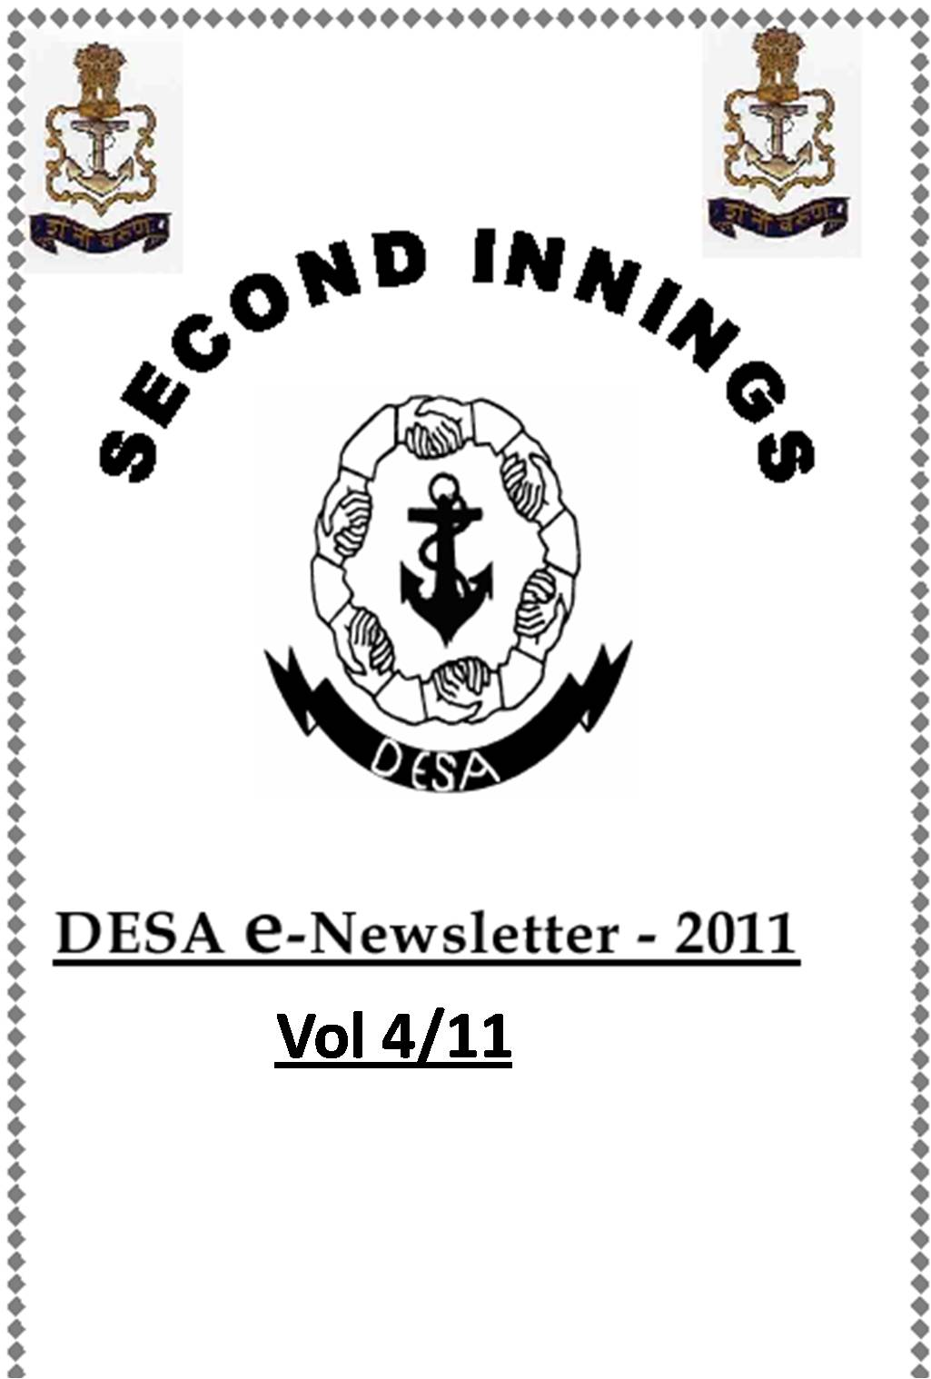

PREFACE

Dear Reader

1. The fourth edition of DESA E- News letter is before you. In this edition, we have tried to give updates on the happenings in the Navy with respect to improving the conditions of naval veterans, widows and their wards.
2. Specifically, the issue contains information regarding:-
(a) Recently set up Naval Regimental System (NRS).
(b) ECHS, INPA and VSF updates.
(c) GoI Policy letter regarding pay fixation for those who take on re-employment with Central Govt (paid from civil estimates) in their Second Inning. This letter would open by double clicking on the provided link.
3. Please do send us your valuable feedback and suggestions for further improvement of this News Letter.
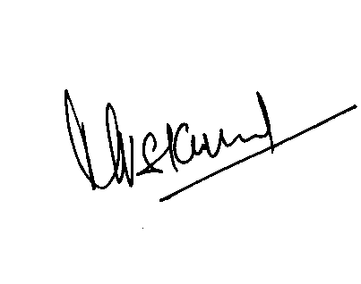
(MVS Kumar) Commodore PDESA 22 Mar 11

NAVAL REGIMENTAL SYSTEM (NRS)

1. Navy has been providing support to widows/NoK/dependents on an as is feasible basis. However, a need was felt to bring about a paradigm shift and institutionalise a support system akin to the Regimental System in the Army, so as to provide proactive and protracted support by taking full responsibility of our Widows/NoK.
2. Therefore, with the aim to make the service responsible to reach out to each and every family post demise of a Naval colleague, immaterial of whether the individual was in harness or retired, Navy is in the process of setting up a system which ensures that even after the departure of our colleagues, their widows and dependents have the Naval system firmly behind them to guide, help and take care of them. Besides ensuring completion of all paper work for getting them their entitled dues, efforts would be made to help them tide over other difficulties as well. This system would be called as Naval Regimental System (NRS). The following organisation has been brought in force wef 01 Feb 11:-
(i) Chairman. Controller Personnel Services (CPS) is the Chairman. He is the nodal point at IHQ MoD (N) and responsible for overall co-ordination and functioning of NRS.
(ii) Vice Chairman. Principal Director Ex-Servicemen Affairs (PDESA) at IHQ/MOD (N) & CSOs (P&A) at Command level are the Vice Chairman and functional heads to ensure implementation and functioning of NRS.
(iii) Command Regimental System Officer (CRSO). Command Regimental Cell headed by Command Regimental System Officer (CRSO) would be established at different locations as per Enclosure I. Keeping in view the vast area of responsibility, ENC would have two CRSOs, one functioning from Vizag and the other at Kolkata under NOIC (WB). Similiarly, for North India, two CRSOs would be positioned at New Delhi under INS India. The CRSOs would function under the respective Vice Chairman to address all issues related to NRS. He would be responsible for families of deceased Naval personnel located in the geographical area earmarked under his jurisdiction. Whenever feasible, CRSO is to attend to the grievances of pensioners as well.
(iv) Regimental State Unit (RSU). Major shore establishments would be tasked to look after particular state/states under their jurisdiction. For the sake of efficiency, while designating RSUs, it has been decided to distribute the work load amongst the various shore establishments rather than just tasking the major depot establishments in each Command Headquarters. RSUs in consonance with CRSO, will be responsible to physically reach out to each widow/NoK residing in that state. A number of states do not have any major Naval Establishment; hence a list of nominated RSUs based on proximity of the major establishment to the states is placed at Enclosure II.
(v) Regimental Coordinating Unit (RCU). Minor Naval/NCC Units located in various districts will function as RCUs and would be the first point of contact with the Widows/NoKs residing in the geographical area under their jurisdiction.

3. Charter of CRSO/RSUs/RCUs. CRSOs, RSUs and RCUs will function in close co-ordination with each other. The CRSO and his staff would be the prime movers and main executors of the NRS. The RSUs will augment the efforts of CRSO for undertaking various tasks including administrative support and deputing personnel to visit the families of deceased personnel. The RCUs would be the first point of contact with the family of deceased or retired personnel.
4. The NRS would cover the following areas of concern:-
- Provision of widow’s hostel in the area.
(b) Guiding the widows for investment of finances in the State Housing programmes or any other suitable programmes.
(c) Providing assistance in solving of family disputes involving JA, local bodies, village elders, etc.
(d) Provision of counseling with the assistance of NWWA and other NGOs in the area.
(e) Regular updating of personal data of widows and pensioners.
(f) Interaction with State Govt authorities for state benefits to widows/pensioners.
(g) Attend regional civil liaison meetings.
(h) Any other issue involving widows’ rehabilitation.

ECHS Update
5. Status. As on date ECHS membership is 11.5 Lakhs and total beneficiaries are 36.5 lakhs. 227 Polyclinics are fully functional as on date. 133 military hospitals are providing the Medicare to veterans subject to availability of facilities/beds. As on date 1395 Private hospitals have been empanelled. 90% of Medicare is provided at Polyclinics, whereas 5% Medicare is provided at military hospitals and empanelled private hospitals. Capital expenditure incurred till date is 62 Crores on account of procurement of land, construction of polyclinics and purchase of medical equipments. The revenue expenditure this year is 1000 Crores which is mainly due to private hospitals bills, drugs and payment of staff. The ECHS membership has been extended to CG, DSC, TA & NDG.

6. Recent Developments by Govt. Setting up of 199 new polyclinics and 15 regional centers has been approved. The additional budget required for setting up of new polyclinics is one time Capital expenditure of 130 Crores and revenue 45 crores per annum. In addition to the eight polyclinics (Mumbai, Powai, Karwar, Vizag, Kochi, Bhubaneswar, Balasore & Port Blair) managed by the Navy at present, eleven more polyclinics at Navi Mumbai, Vasco, Preet Vihar, Angul, Sambalpur, Srikakulam, Dhenkanal, Puri, Ramanathapuram, Moovattupuzah and Thodapuzha will also be managed by the Navy and five polyclinics (Chiplun, Mahad, Tirunelveli, Kakinada and Nerul) will be taken over from Army.
7. Way Ahead. The Government is considering outsourcing of medicines, which is now 360 Crores and Private Hospital Bills Processing, through third party arbitrator i.e UTI/TSL. Govt. has approved for the empanelment of hospitals under the National Board of Accreditation for Hospitals and Healthcare providers (NABH) for ECHS which will reduce the existing period from two years to two weeks. The automation of ECHS is also under process. Tele-medicine is another area ECHS is looking at which will give chance to people in remote areas to consult specialists. Mobile polyclinics operating in areas, where good doctors are available for instant referrals is also under consideration.

AGM of Veteran Sailors’ Forum (VSF)

8. In a short span of time the Forum has now grown to 13 Charters and the membership strength has increased by 180% in the past one year to 3500. From mid last year the retiring sailors’ are being enrolled at CABS itself and the regional associations of ex-servicemen are proactively being targeted to further increase the strength.

9. The 3rd GCM/AGM of VSF was conducted at Mumbai on 27 Feb 11 (Sunday). The Governing Council Meeting was held at HQWNC Board Room followed by Annual General Meeting at INS Angre Auditorium. More than 350 members of the region attended the meeting. Vice Admiral SPS Cheema, NM, AVSM Controller of Personnel Services (CPS) chaired the GCM/AGM. Issues concerning veterans were discussed in great details. The issues included Pension, Canteen, ECHS and other welfare schemes/benefits for the Veterans. CPS apprised the members of the Naval Regimental System (NRS). The GCM/AGM was followed by lunch and VSF caps were distributed to members as a token of remembrance. The minutes of the meetings are at the final stage of preparation and would be hosted shortly.

Indian Naval Placement Agency
website www.inpa.net.in
email inpacareers@yahoo.com
10. The Indian Naval Placement Agency has been instrumental in providing job opportunities to ex-naval personnel since 2006. As on date there are 1413 active candidates registered with INPA. These include ex naval personnel, widows and dependents. Confirmed placements as on date, by INPA, are 964.
11. Mumbai Metro Rail has intimated that they are going to recruit 123 ex-servicemen. All retiring / retired personnel of Engine / Electrical / Communication background are advised to register with INPA and forward their willingness to avail this job opportunity.
12. It is envisaged that Directorate General of Lighthouses and Lightships will be recruiting ex RP sailors as Vessel Traffic Service (VTS) Console Operators Grade I / II in coastal areas.

13. Copy of GOI letter 3/19/2009-Estt (Pay II) dated 05 Apr 2010
Regarding Applicability of CCS (RP) Rules, to Persons Re-employed in Govt service After Retirement and Whose Pay is Dubitable to Civil Estimates

Double Click here

